
NAME: M NASEEM
ROLL NO: 055
SECTION: BSSE-4A
SUBJECT: AI(lab)
SUBMITTED TO: RASIKH ALI

Depth-Limited Search (DLS) and Iterative Deepening DFS (IDDFS)
1. Introduction
In this task, I applied DLS and IDDFS employing the same A, G graph from Section 3.2, to a significant degree.
DLS: Searches the graph up to a fixed depth limit.
IDDFS: Runs DLS repeatedly, increasing the depth limit each time until the goal is found, in real-world scenarios.
The root node A is currently counted as depth 0, so on top of that, the goal node is often G, in actual application.
2. Original Graph
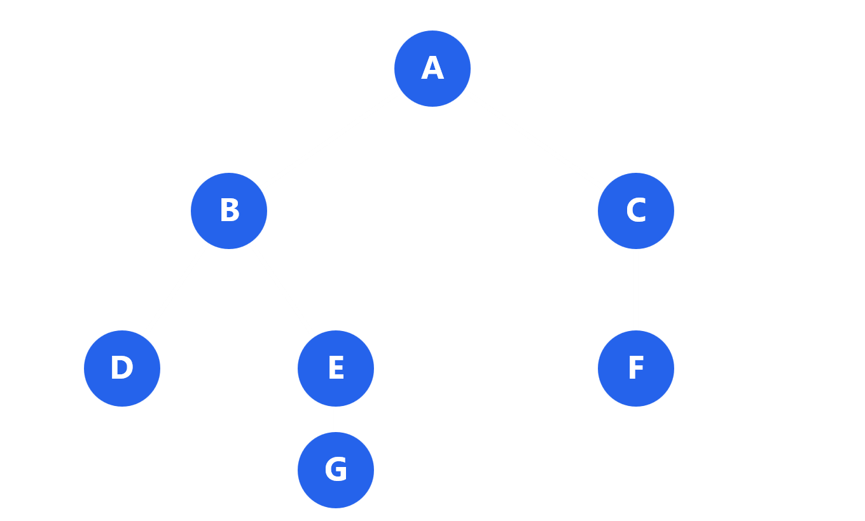
Start: A | Goal: G | Successor order, such as left to right
Depth of each node:
Node | Depth
A | 0
B, C | 1
D, E, F | 2
G | 3

3. Python Code for DLS and IDDFS
A path-local cycle check was employed so that the search doesn't visit the same node again on its current path, in many respects.

The code employs three statuses:
FOUND: The goal node G is generally found.
CUTOFF: The depth limit stops the search before it can (in practical terms) explore further.
FAILURE: including No goal is mainly found and there are no more paths to check out, on the whole.
4. DLS Test Results
I tested DLS four times employing distinct depth limits.
Depth limit | Nodes visited | Status | Final path
1 | A, B, C | CUTOFF | Not found
2 | A, B, D, E, C, F | CUTOFF | Not found
3 | A, B, D, E, G | FOUND | A → B → E → G
4 | A, B, D, E, G | FOUND | A → B → E → G

Explanation:
Limit 1: The search can't reach G because it's too deep.
Limit 2: The search is reaching E but can't continue to G.
Limit 3: namely The search is reaching G and finds the goal.
Limit 4 : The search also finds G at depth 3. In turn, and yet, the extra depth isn't needed, broadly speaking.
5. IDDFS Test Results
IDDFS At a time, augments the depth limit one step. It's stopping when the goal is typically found, in actual application.
Maximum depth | Limits tried | Status | Final path
1 | 1 | CUTOFF | Not found
2 | 1, 2 | CUTOFF | Not found
3 | 1, 2, 3 | FOUND | A → B → E → G
4 | 1, 2, 3 | FOUND | A → B → E → G
Significant: For maximum depth 4, IDDFS is stopping at depth 3, because it has already found G. Clearly, it doesn't need to try depth 4, broadly speaking.
6. Why Does IDDFS Repeat Some Work?
IDDFS runs DLS again with a higher depth limit each time.
For example:
At limit 1: it checks A, B and C.
At limit 2: it's checking those nodes again and checks out further.
At limit 3: it searches again and finally reaches G.
This means some nodes are visited more than once, but still, this is how IDDFS makes sure it doesn't miss a goal at a smaller depth, on the whole.
7. Why Do Limits Below 3 Not Succeed?
The goal node G is usually at depth 3.
Limit 1: can't reach G.E can be reached by
Limit 2: Though, g is one level deeper.
Limit 3: reaches G successfully.G is also found by
Limit 4: but the extra depth is normally unnecessary.
Difference between the three statuses:
Status Meaning
FOUND Goal is found.
CUTOFF Search is stopping because of the depth limit.
FAILURE No goal is usually found and no unexplored paths remain.
What's more, the goal is found at limit 3. Indeed, only the same, fAILURE doesn't emerge, because the smaller limits are yielding CUTOFF in these tests, in actual application.
8. Conclusion
DLS and IDDFS were implemented employing the original graph in this task.
DLS found the goal when the depth limit reached 3, which is why IDDFS also found the goal by increasing its depth limit step by step, on the whole.
Both methods returned the same final path:
A → B → E → G
These outcomes are making it clear that limits below 3 aren't enough to reach the goal, broadly speaking. IDDFS repeats some work. That said, it successfully is finding the goal without needing to start with a large depth limit, in real-world scenarios.

